**Classes Photos for the year 2024.**

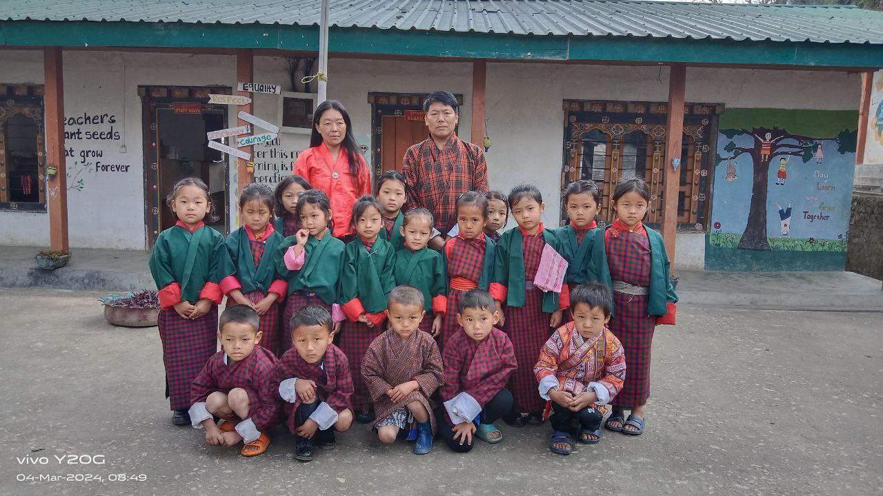

*Class I, class teacher Tshering Norbu and Principal*

*Class PP, class teacher Dorji Seldon and Principal*

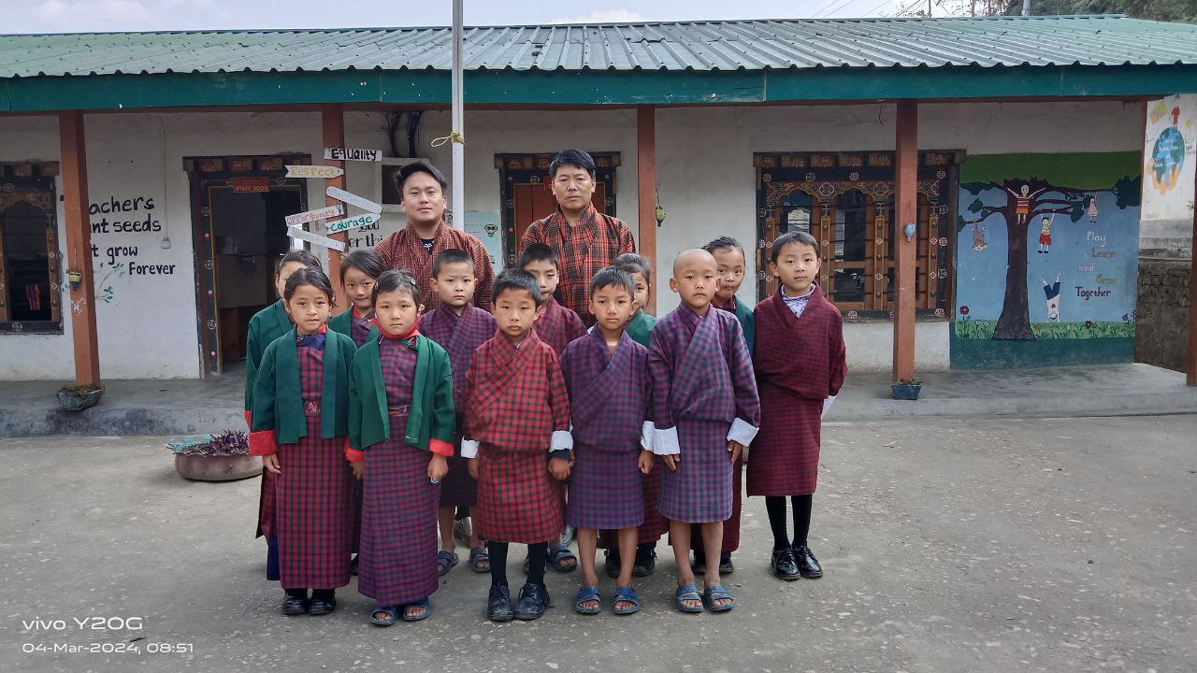

*Class II, class teacher Pema Thinley and Principal*

*Class III, class teacher Chencho Dema and Principal*

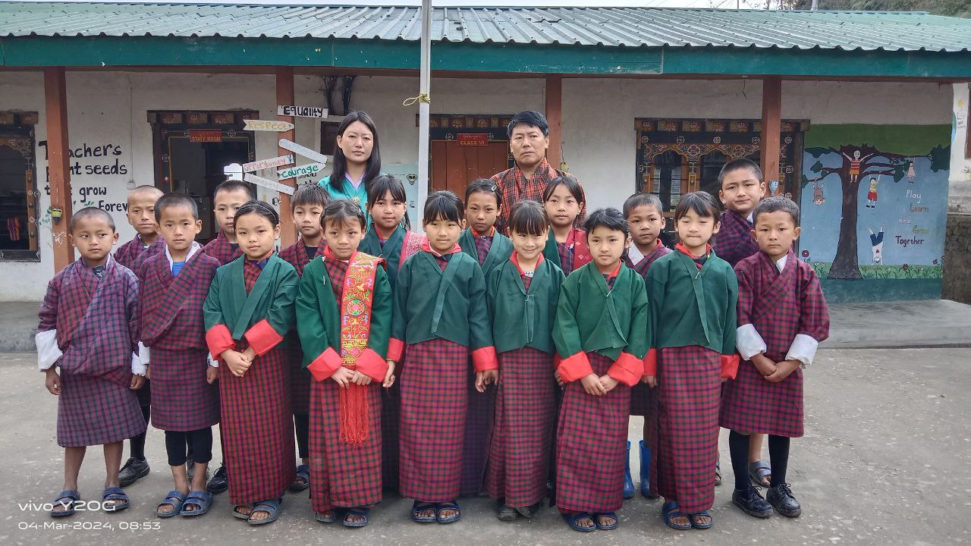

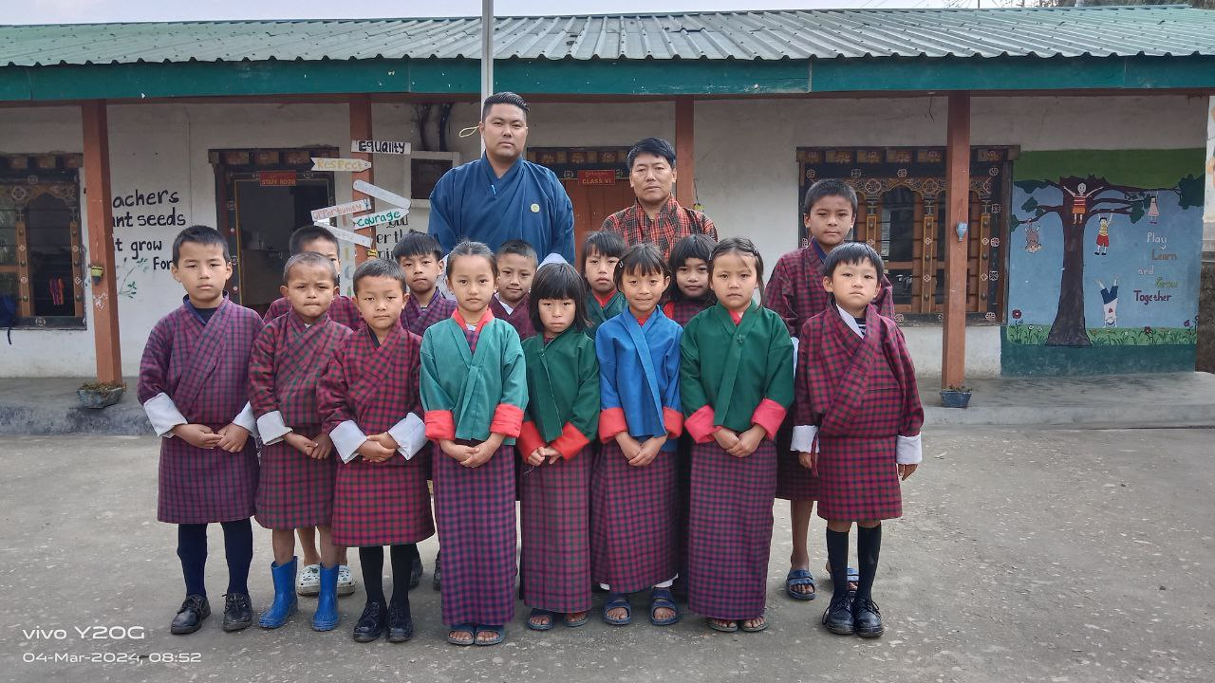

*Class IV, class teacher Tandin Lhamo and Principal*

*Class V, class teacher Pema Zangmo and Principal*

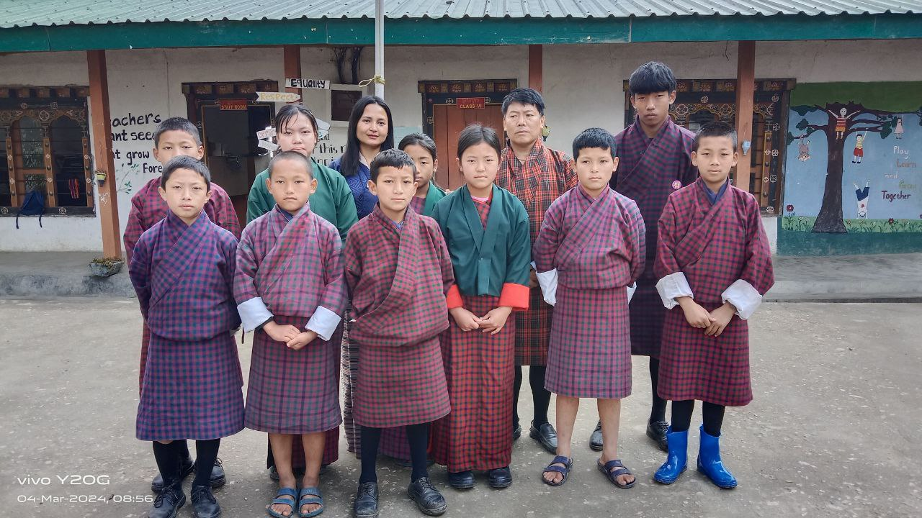

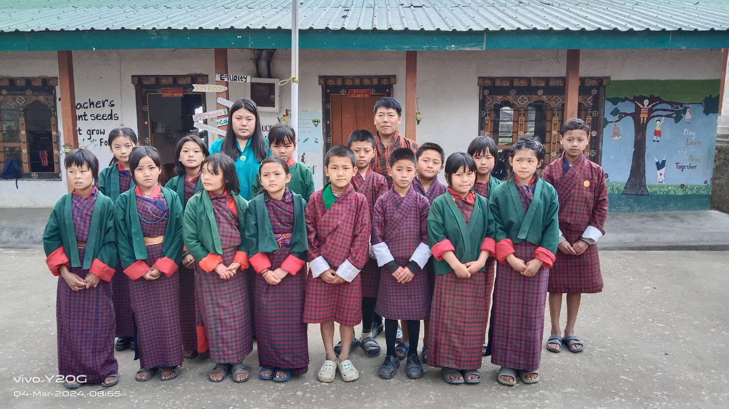

*Class VI, class teacher Sonam Tshewang and Principal*

*Students group photo class PP-VI*

